**IDEATION PHASE**

**EMPATHY MAP & DISCOVER**

|  |  |
| --- | --- |
| DATE | 18 JUNE 2025 |
| TEAM ID | LTVIP2025TMID52211 |
| PROJECT NAME | COSMETIC INSIGHTS:NAVIGATING COSMETIC  TRENDS AND CUSTOMER INSIGHTS WITH TABLEAU |
| MAXIMUM MARKS | 4 MARKS |

**EMPATHY MAP FOR COSMETIC INSIGHTS**

This empathy map for cosmetic insights visually captures a consumer's mindset across four key dimensions:

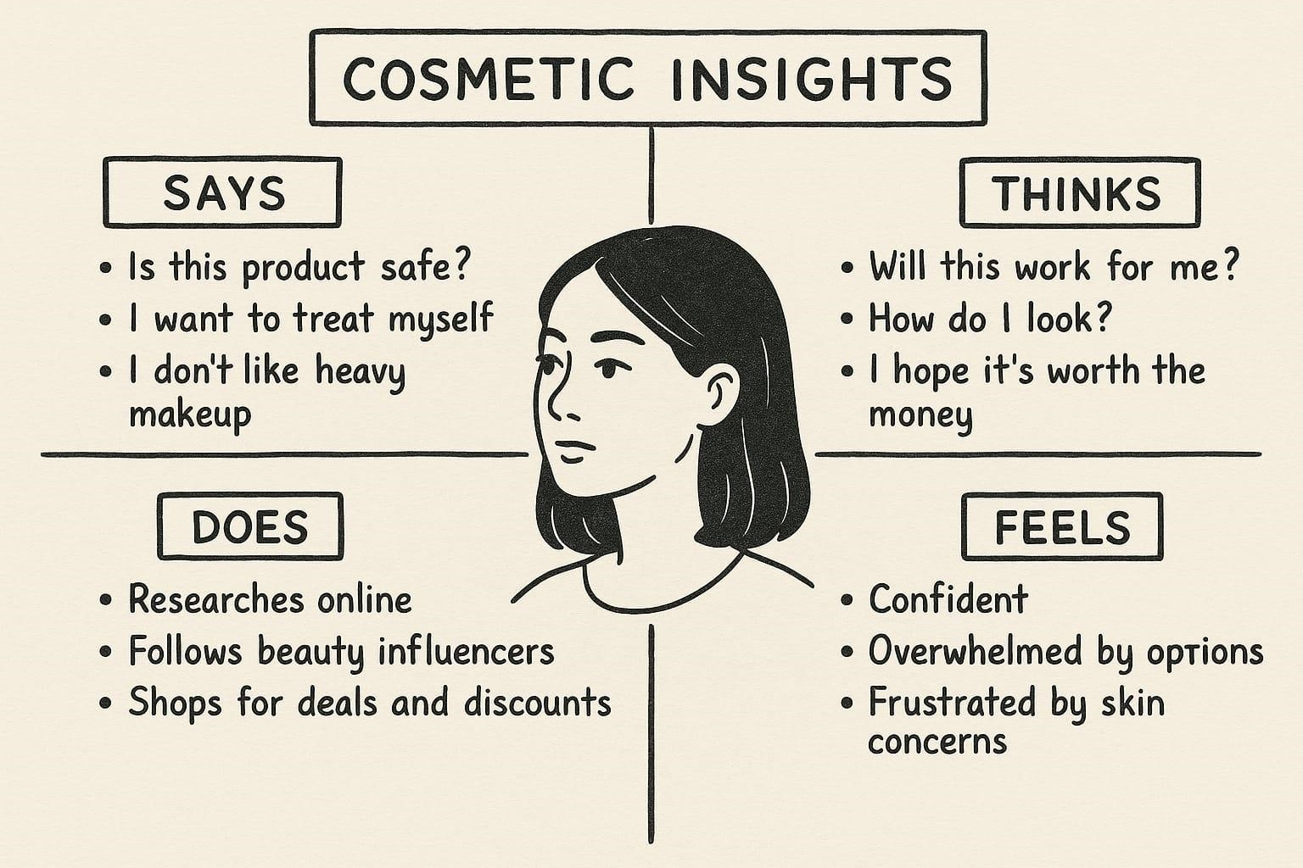

* **Says:** What the user verbalizes, including their direct quotes and opinions.
* **Thinks:** The user's thoughts, beliefs, and opinions about the product or service.
* **Does:** The user's actions and behaviors when interacting with the product or service.
* **Feels:** The user's emotions and feelings related to the product or service.

The cosmetic consumer is cautious but self-indulgent, heavily influenced by online research and trends, and experiences a mix of confidence and frustration due to the abundance of choices and personal skincare challenges.